Name: **SortNamesGUI**

Description: **Chapter 8 – Programming Exercise 9**

**Collect and sort first names**

Write a C# GUI application that includes a method that accepts any number of names and sorts them in alphabetical order. When the user clicks a button, demonstrate that the application works correctly when the method is called with two, five, and ten names. The inputButton is to be designated as the Accept button. The exitButton is to be designated as the Cancel button. Access Keys are to be assigned to all buttons on the GUI. Set the Tab index to a logical order. Design your GUI as shown.

Create a Click event method for the inputButton. Within the method, declare the necessary variables and appropriately convert user input. Determine if the user entered a 2. If a 2 was entered, declare a string array that has two elements. Use a *do* loop that presents an input box that allows the user to enter two names. Populate the array with the two names entered by the user. The do loop is to remain active *while* the controlling variable is less than or equal to 1. Call the method that is responsible for sorting and displaying the names. Repeat these tasks when the user wants to enter 5 names. Repeat these tasks when the user wants to enter 10 names.

Create a method that accepts an array from its caller. Within the method, sort and display the names. Items in the display label are to appear as shown.

Create a Click event method for the exitButton. Its only task is to terminate the application.

Complete the Pseudocode Template document for this programming request. A printed version is due upon arrival to class on lab day.

Use your completed Pseudocode document to create the C# application. Create and save the application to your classroom USB flash drive.

GUI when started

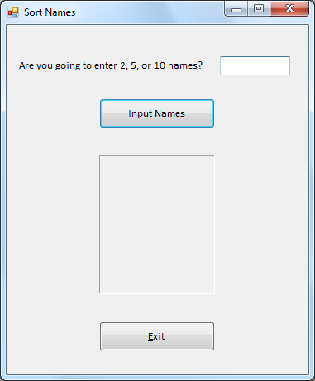

Sample Program Output (1)

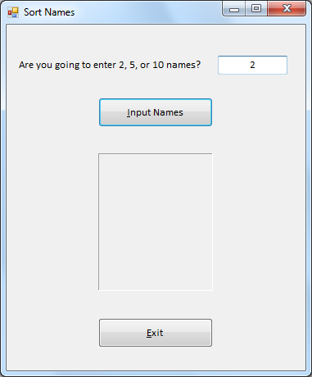

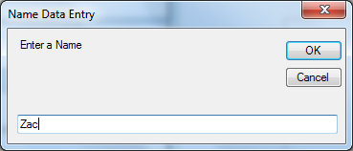 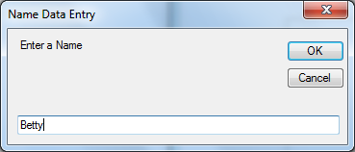

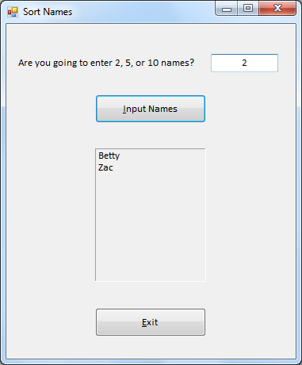

Sample Program Output (2)

